# Requirements Definition

## Group 1

Job Find

### Introduction and Context

The purpose of this project is to build a system for facilitating community yardwork job offers. It will serve as a profitable means to match young workers with customers offering jobs. The site owner will not employ anyone, rather act as a job finding provider that receives a surcharge for making a connection between the customer and worker.

To populate the system with listings, customers will have the ability to sign up and post the type of job they have available, and when they are hoping to have it completed. They will also add a balance to conveniently handle payment to the worker that completes their job listings. Once they have listed a job, the system will match it with an available worker.

The system will allow workers to create accounts and set their availability. Jobs will be rewarded to workers on a fair basis, with a slight preference system in place for those with higher ratings from customer feedback. They may specify the type of jobs they’re willing to accept and will be notified when one is available. Once a job is accepted by a worker, they will receive contact information for the customer and be expected to complete the job.

Upon completion, the worker will notify the system that the job is complete, and money will be transferred accordingly. 90% of a listed job wage will be rewarded to the worker, and 10% to the site owner. Both parties will have the opportunity to leave feedback on each other.

* This system will provide a convenient means for young people wanting to make money to connect with customers needing work done around their yard without having to create an individual advertising scheme.

### Users and Goals

The purpose of this section is to describe the system’s actors and how they aim to interact with the system using UML use case diagrams.

*Figure 1 – User creates a new account*

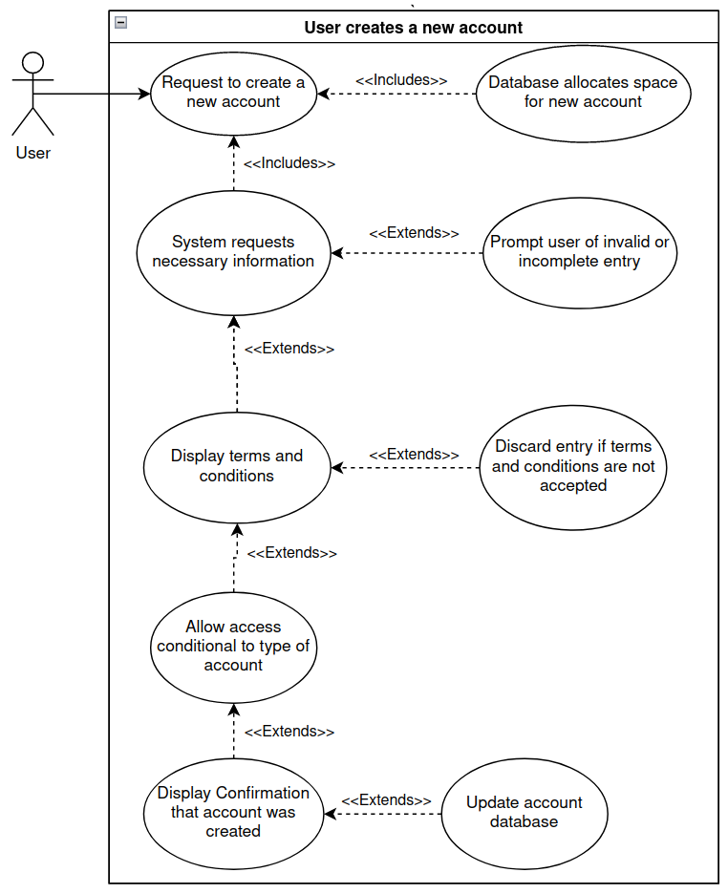Participating actors: Customer, Worker

Entry conditions:

* User wants to create an account

Exit conditions:

* User creates a new account
* User cancels account creation

Event flow:

1. Customer clicks on link to create account
2. Customer fills in necessary information
3. Customer is given the terms and conditions
   1. If terms are accepted, account is created
   2. If terms are not accepted, account is not created

*Figure 2 – Customer creates a job request*

### Participating actors: Customers

Entry conditions:

* Customer is logged in

Exit conditions:

* Customer creates a new job request
* Customer cancels creation of job request

Event flow:

1. Customer logs in
2. Customer requests job creation
3. Customer inputs information pertinent to the job
   1. The customer cancancel their request at any point in this process
   2. If the customer follows through with the request, they are notified that the job was created correctly

*Figure 3 – Customer adds funds to their account*

### Participating actors: Customers

Entry conditions:

* Customer is logged in

Exit conditions:

* Customer adds a certain amount of funds to their account

Event flow:

1. Customer logs in
2. Customer requests that funds be added to their account
3. Funds to be used to pay workers are added to the account

*Figure 4 – A worker is assigned a job*

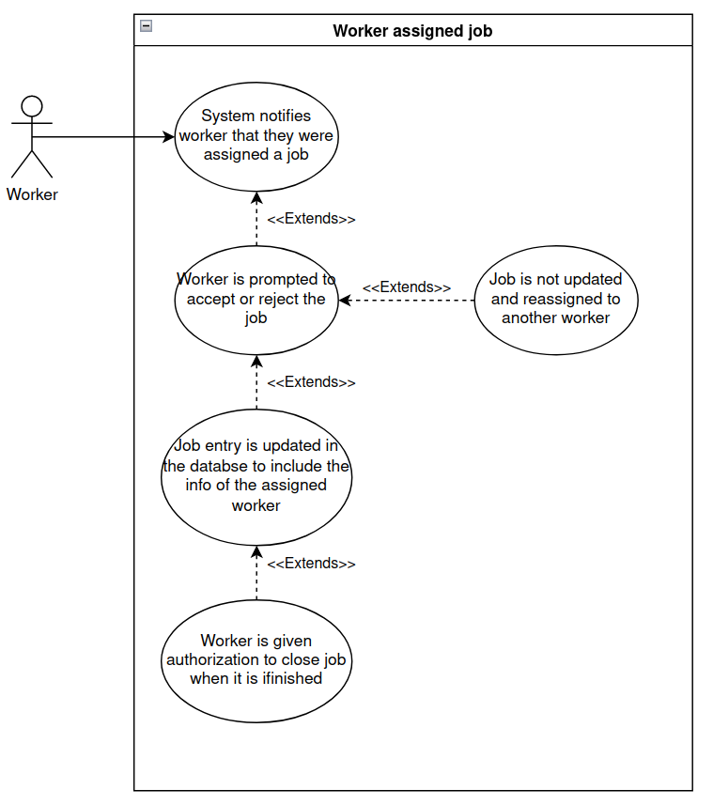

Partcipating actors: Worker

Entry conditions: Worker is logged in

Exit conditions:

* A worker accepts the job
* A worker rejects the job and it is passed to another worker

Event flow:

1. The system notifies the user that they have a job request assigned to them
2. The worker is prompted to accept the offer
   * If they accept the offer, they are assigned to the job in the database
   * If they reject the offer, it is reassigned to another worker

*Figure 5 – A job is finished*

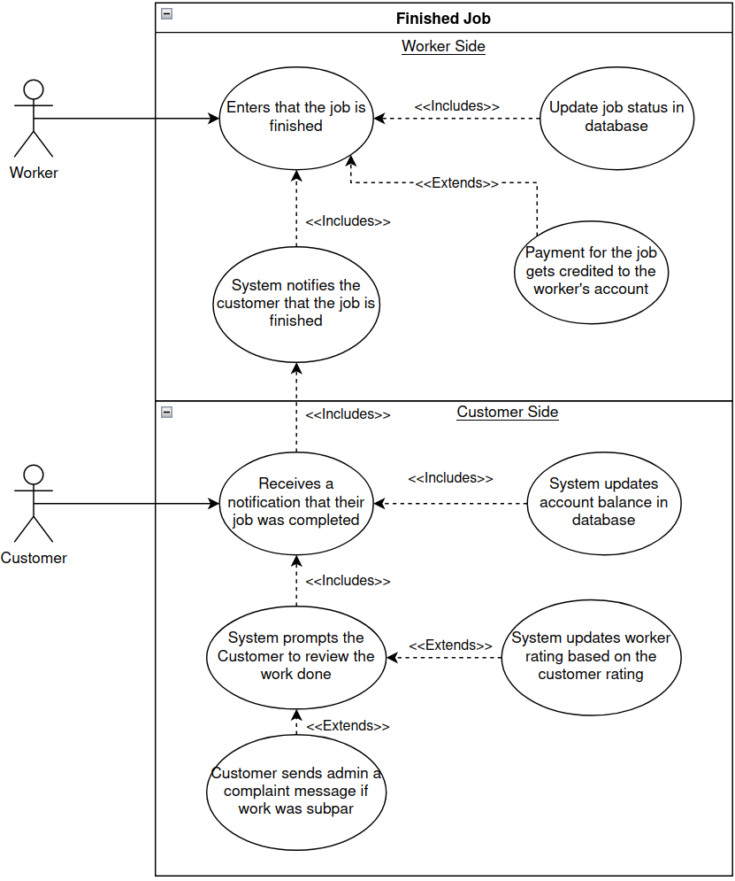

Participating actors: Worker, Customer

Entry conditions: Worker indicates that the job is finished

Exit conditions: Customer writes a review of the job done

Event flow:

1. Worker indicates that the job is done
2. Worker is paid for their work
3. The system notifies the customer that their job is finished
4. The customer reviews the work done and enters a review into the app
   * The customer can file a dispute if the work was done incorrectly

### *F**igure 6 – User edits profile*

Participating Actors: Workers, customers, owners

Entry conditions: User is logged in

Exit condition: The user is notified whether their requested changes were accepted

Event flow:

1. A worker or customer logs into their account
2. They request a change to their account information
3. They enter the edits into the account
4. The owner receives the request for an account change
5. They can accept or reject the edits that were requested
6. The user is notified that the changes were either accepted and rejected

### *Figure 7 –* *Owner reviews a dispute*

Participating actors: Owners

Entry conditions: Owner is logged in

Exit conditions:

* The customer is notified of the decision made on their dispute
* The worker is notified that a refund was issued

Event flow:

1. Owner logs into their account
2. Owner receives dispute
3. If owner decides to issue a refund:
   1. Refund is taken from the workers account
   2. The worker is notified that a refund was issued
4. The customer is notified of the owner’s decision

### *Figure 8 –* *Owner edits job types*

Participating actors: Owners

Entry conditions: Owner is logged in

Exit conditions:

* Changes are made to one or more of the job types
* Edits are cancelled and nothing is changed

Event flow:

1. Owner logs into their account
2. Owner requests to edit the job types in the system
3. Owner makes edits to the job types, including adding new types and deleting existing ones
4. The owner can cancel changes before they are saved or save the changes to the database

### Functional Requirements

This section focuses on requirements related to how the system is expected to behave.

1. User Authentication and Account Management
   1. The initial page will ask the user to sign in or sign up.
   2. Registration
      1. If the user clicks on the signup button, they will be taken to a page with a form.
         1. Users must sign up with a username, password, email, and phone number.
         2. Users will have the option to add a profile picture or graphic.
         3. There will be a button to confirm registration.
            1. If there are missing fields or other errors, a message will be displayed back to the user.
            2. If it is successful, the user will have to accept terms and conditions to create the account.
         4. Upon a successfully created account, the user will have the option to select a worker or customer account type.
            1. They can leave the site and return later with their spot saved.
            2. Workers will be taken to an extended form.
         5. Worker Registration
            1. A worker must enter their availability.
            2. A worker must enter the types of jobs they’re willing to accept.
         6. Upon completing the registration process the user is taken to the home page.
   3. Logging in
      1. Users with active accounts will sign in with a username and password each session.
         1. There will be fields for the username and password on the initial page, along with a button to sign them in.
      2. Incorrect attempts will result in an error being displayed back to the user.
         1. The error will let the user know that the email or password was invalid, or that another error was encountered, prompting them to try again.
   4. Account Management (All Users)
      1. A user must be logged in to access account management features.
      2. Any type of user will be allowed to change any account details aside from the account type and username, including email, password, phone number, and profile pictures.
      3. A user should be able to view account balance.
2. Customer Account Features
   1. The key functionality of this user is the ability to post job offers using a built-in template accessible from a home page.
      1. They will be able to specify job type (e.g., lawn mowing)
      2. They will be able to specify a time frame for when the job is to be completed (e.g., Thursday morning).
      3. They will have the ability to specify the estimated time for completion.
      4. They will have the ability to specify payment.
         1. There must be a minimum wage for each job type.
      5. They must have enough funds in their account for the job to be created.
   2. They will have the ability to add money to their account.
      1. Note that for the scope of this project, we will not be using real money. Instead, they will enter an arbitrary number in for the system to work with.
      2. They will click a button to add money, then be prompted to enter a number in. Once saved, their balance will update to reflect the action.
   3. They can leave feedback on workers after a job is complete
      1. They will be provided with a template containing specific categories to rate.
   4. They will have the ability to contact the owner about discrepancies at any point by clicking on a link to a complaint form.
3. Worker Account Features
   1. The key functionality to this type of user is the ability to accept jobs posted by customers.
   2. They must be able to set and edit their availability to take jobs, meaning they will only be assigned jobs that fit within their set availability.
   3. They must be able to set and edit which types of jobs they are willing to be assigned.
   4. They must be able to view jobs assigned to them by the system and have the option to accept or decline them.
   5. They will receive 90% compensation for each completed job.
      1. Each job will display the customer’s offer along with the actual amount they will receive.
   6. They can leave feedback on customers.
      1. They will be provided with a template containing specific categories to rate.
   7. They can mark when a job has been completed.
      1. This will result in funds being transferred to their account.
4. Owner Account Features
   1. A special account will be created for the system owner, and an owner account cannot be created through the typical registration process.
   2. They will receive 10% of compensation for each completed job.
   3. They will have a page only accessible to them for system management purposes.
      1. They can add and delete types of jobs.
         1. This would involve adding and removing job types from the drop-down list customers see when posting a job offer.
         2. Adding a job would allow customers to create job offers with that type and workers to declare they are willing to do the job type.
         3. Deleting a job will not affect current job offers but will delete it from the form when creating new jobs.
      2. They have the privilege to move money between accounts for reimbursement purposes.
      3. They can view complaints.
   4. In addition to these special features, they will also have the same access to processes that customer and worker accounts have.

### Non-Functional Requirements

This section focuses on requirements related to how the system will work.

1. The system must utilize a database.
   1. The database will store user information.
      1. This includes permissions, username, password, email, phone numbers, ratings, account balances, and profile pictures.
         1. Worker accounts will store availability and job types as well.
   2. The database will be used to store information on job postings.
      1. This includes job title, description, type, address, estimated completion time, compensation, desired completion window, customer, customer contact information, status, and worker (if assigned).
         1. The customer contact information should only be accessible by the customer who created the offer, the worker assigned to it, and the owner.
2. The system design must be data-driven and dynamic.
   1. Updates to the database should affect other areas of the system.
3. The team will use Git as a version control system, with GitHub.
   1. The team will use GitHub Project to manage backlogs.
4. The system must be deployable either locally or by a cloud service.
5. The system must support mobile devices.

### Future Features

This section focuses on possible additions for future versions that aren’t necessary to the MVP.

1. The system could implement a filter by location feature to account for the distance between workers and customers.
   1. Workers would have the option to set maximum distances.
2. The system could implement a preference system where customers could add ‘favorite’ workers to give priority to for their job offers.
3. The system could implement the ability for a customer to set up a recurring job offer.
4. An alert system via email/SMS/Push could be implemented to let users know when jobs are available and accepted.
5. The database could track the history of jobs and a report could be displayed back to users.
6. The system could implement a tip system to adjust wages.

### *Glossary*

This section defines a list of terms relevant to the project.

*Owner -* a user with elevated privileges that profits from connections and can manage job types, refunds, and user conflicts

*Worker -* a user that is looking to complete job offers for compensation

*Customer -* a user that is looking to provide compensation for a job offer

*Job -* a specific task related to yard work managed by the owner and specified by the customer for a worker to complete

*System -* the software application this project aims to create; the product being built

*User -* an owner, customer, or worker with specific access according to the user type

*Database -* storage for system data to be stored (e.g., user and job details)